Abu Dhabi  Beijing  Berlin  Buenos Aires  Chicago | Hong Kong  Istanbul  Johannesburg Kuala Lumpur  London  Los Angeles | Madrid  Mexico City  Milan  Moscow  Mumbai | New York  Paris  San Francisco  São Paulo  Seoul  Shanghai | Singapore  Stockholm  Sydney Tokyo  Toronto
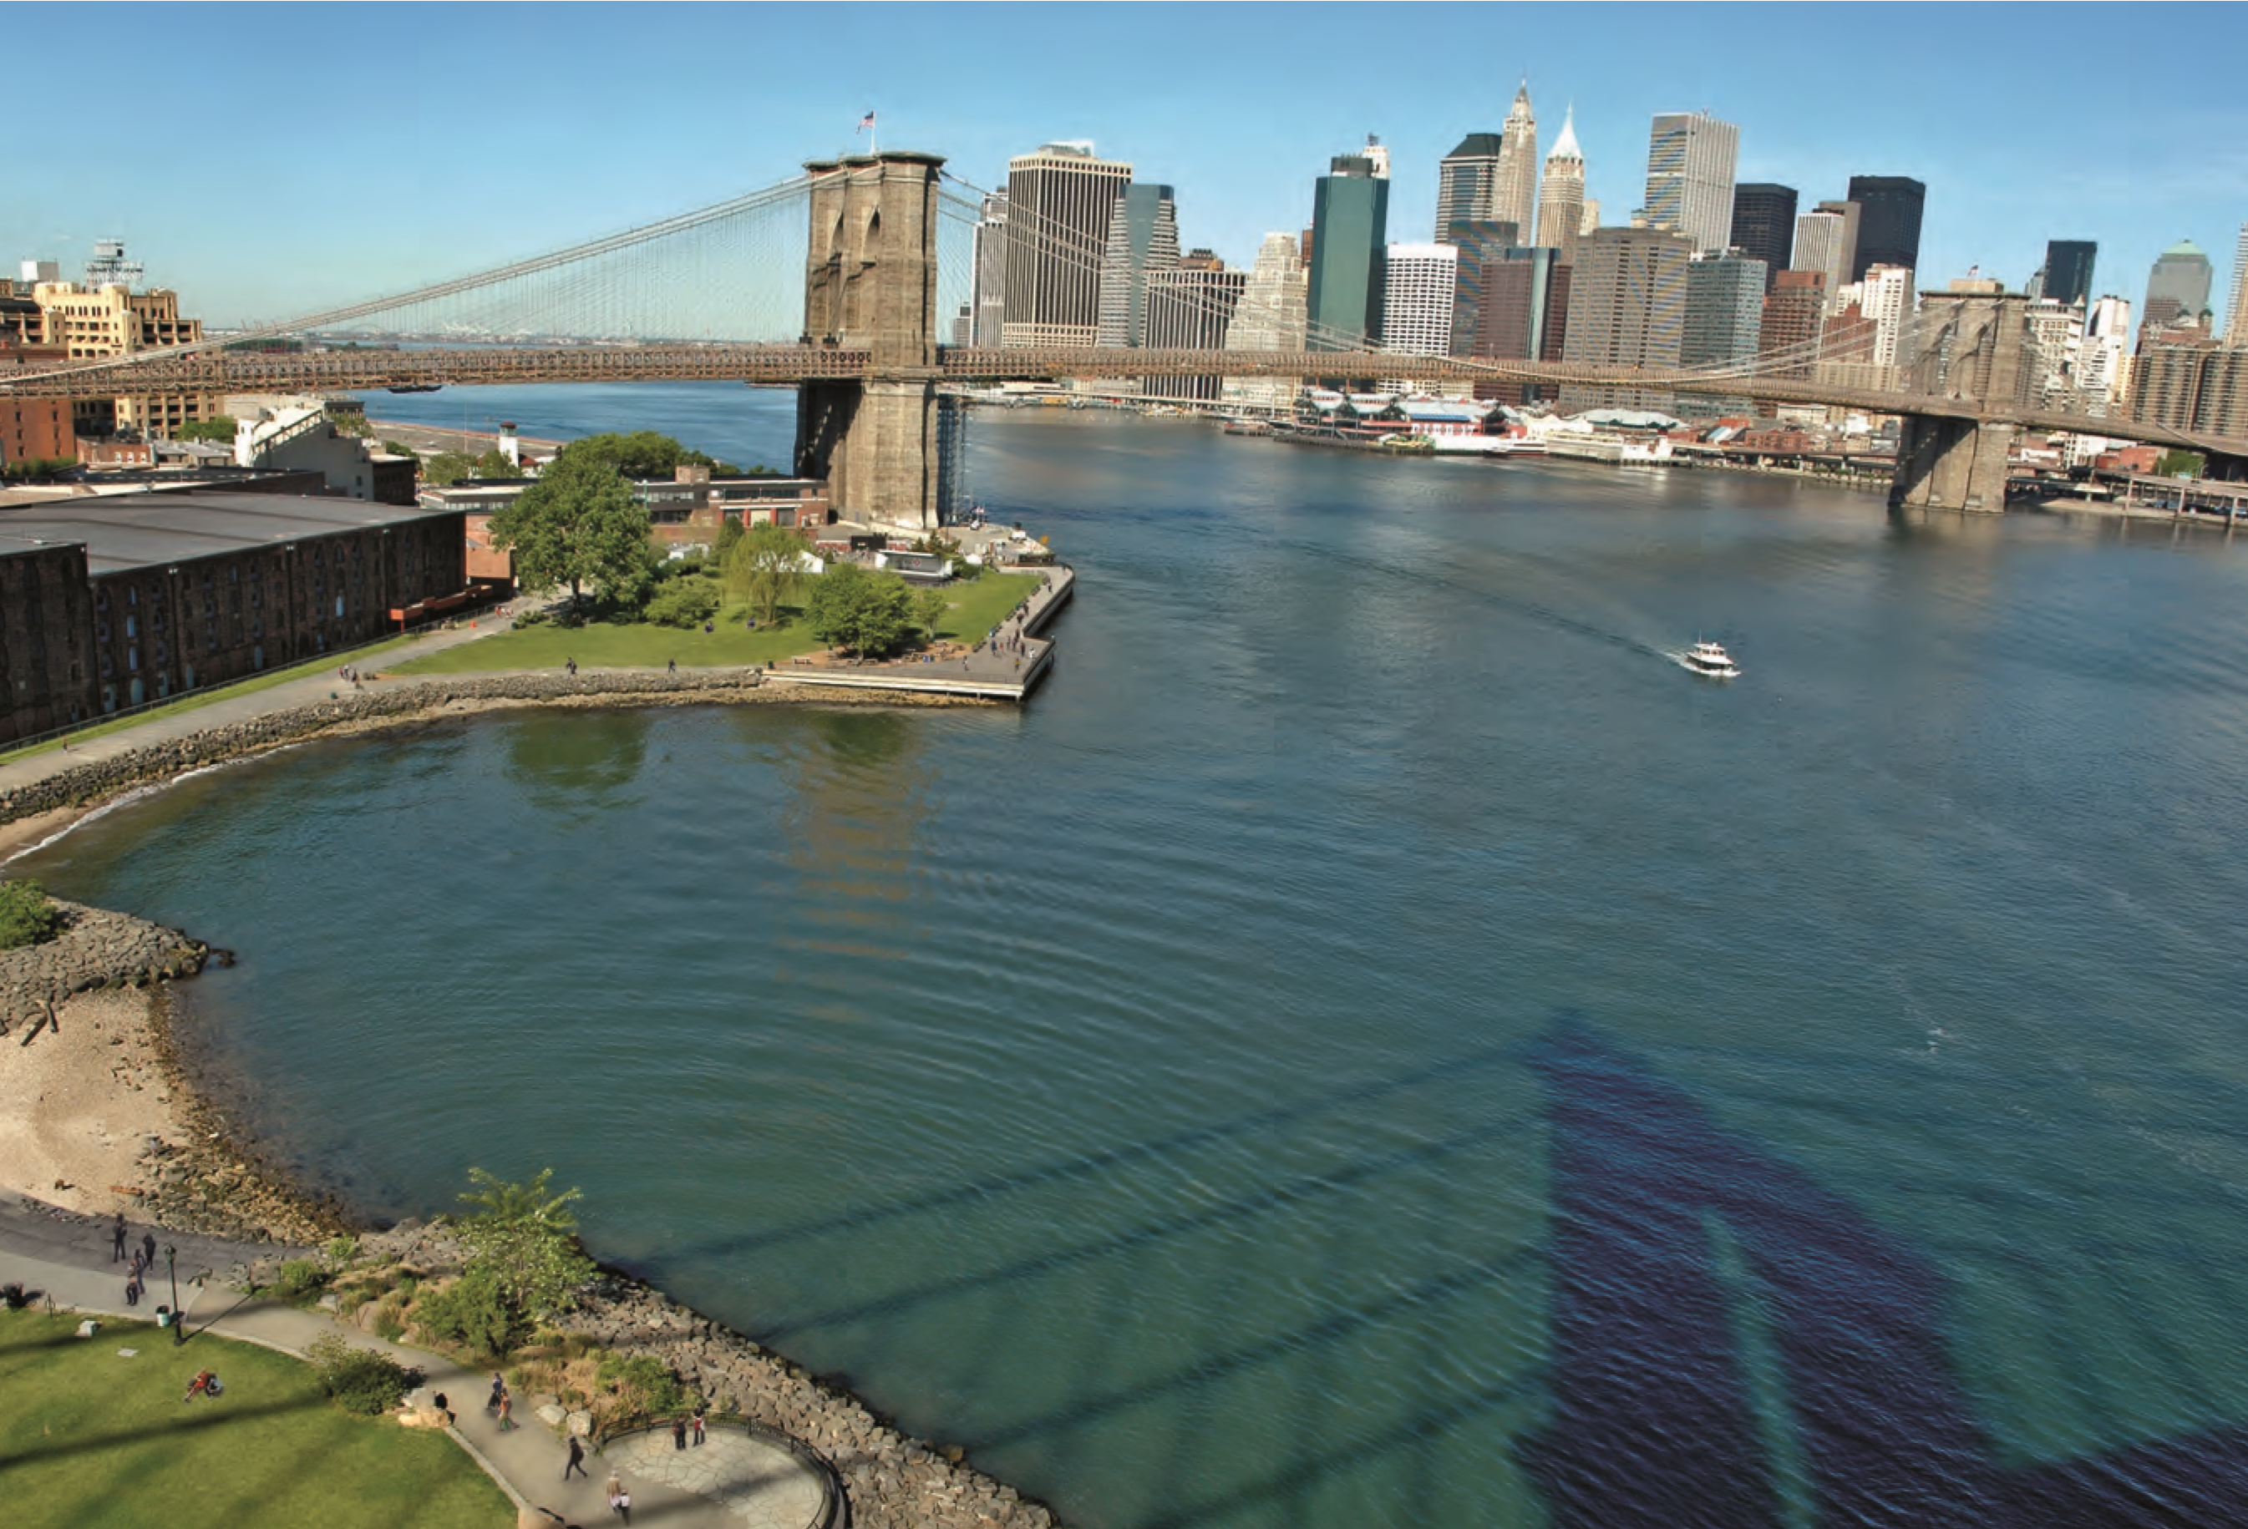
Cities of Opportunity

Cities of Opportunity 2012
analyzes the
trajectory of 27 cities, all capitals of finance,
commerce, and culture—and through their
current performance seeks to open a window
on what makes cities function best. This year,
we also look ahead to 2025 to project
employment, production, and population
patterns, as well as “what if” scenarios that
prepare for turns in the urban road.
Cover image: Brooklyn Bridge and Lower Manhattan,
Guillaume Gaudet Photography
www.pwc.com
©2012 PwC. All rights reserved. “PwC” and “PwC US” refer to PricewaterhouseCoopers LLP, a Delaware limited liability partnership,
which is a member firm of PricewaterhouseCoopers International Limited, each member firm of which is a separate legal entity. This
document is for general information purposes only, and should not be used as a substitute for consultation with professional advisors.
www.pfnyc.org
©2012 The Partnership for New York City, Inc. All rights reserved.

Looking to the future of 27 cities at the center

of the world economy
In this fifth edition of Cities of Opportunity, PwC and the Partnership for New York City again examine the current social and economic performance of the world’s leading cities. We also add a future dimension that probes the shape of city economies to come. Together, looking at 2012 results and ahead toward the possibilities in 2025, we seek to provide a realistic framework for thought and action beginning with 27 of the world’s most significant cities—on one hand, the engine of the modern global economy and on the other, the heart of much of our shared culture.
It is precisely because of the importance of cities and the need to deepen knowledge of urban issues that we undertake the study. The effort to question and understand where cities are and where they are headed benefits all of us in a world urbanizing like never before. This includes the officials and policymakers setting the course, businesses invested in city well-being, and the citizens who build their lives in thousands of city neighborhoods worldwide, rich or poor, picturesque or prosaic.
Statistics tell some of the story: Today, our 27 cities account for nearly 8 percent of world gross domestic product (GDP) but only

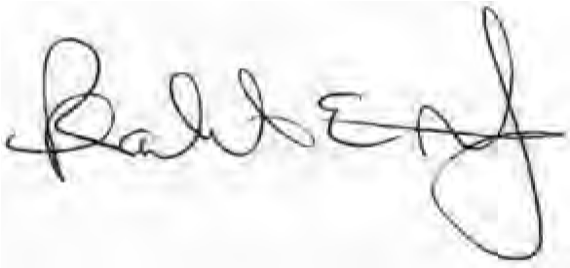
PricewaterhouseCoopers LLP
Robert Moritz
Chairman and Senior Partner
Yours sincerely,

2.5 percent of the population. By the quartercentury, they will house 19 million more residents, produce 13.7 million additional jobs, and generate $3.3 trillion more in GDP if population follows UN projections and economic progress remains modest. As growth occurs, the symbiotic relationship between East and West is likely to continue: Emerging cities will skyrocket in jobs and population, but developed cities will retain the spending power, as well as the consumer and corporate demand, to drive growth. One side will still need the other to move ahead.
Meantime, our analysis shows that each city represents an economic ecosystem in its own right, built around mutually supportive economic and social strengths as well as an intertwined fabric of jobs—not just the professionals in bright skyscrapers but all those who turn the lights on every morning from retailers and teachers to nurses and cooks, from crime fighters to street cleaners. Maintaining healthy balance is a cornerstone of urban resilience.
Our jobs analysis also reveals surprising patterns, vulnerabilities, and dependencies, as cities journey toward 2025 with more than a few clouds on the horizon. To come to grips
Kenneth I. Chenault
Chairman and CEO American Express Co.
Co-chairman
Partnership for New York City
with some of this uncertainty, “what if” scenarios test the future of our cities under different conditions. The clouds hold silver linings for some cities in terms of greater employment and wealth. But storms roll in for others. The differing “what if” scenarios stress the need for flexible thinking simply to deal with foreseeable changes, not to mention the unexpected turns.
To flesh out the empirical picture, we spoke to a broad scope of leaders on issues from the long range and philosophical to the practical and immediate. This includes E.O. Wilson, the naturalist; Bill Bratton, former New York and Los Angeles head of police; Narayana Murthy, founder of Infosys; Andrew Chan and Peter Chamley, two leaders of the global engineering firm Arup, based in Hong Kong and London, respectively; Wim Elfrink, Cisco’s head of Smart + Connected Communities; and David Miller, former Toronto mayor and World Bank special advisor on urban issues.
All in all, we hope to provide insight into an urban world in which all of us are “in it together,” making as strong a case for joint thought and action among cities as there is for self-interest and competition.
Terry J. Lundgren
Chairman, President and Chief Executive Officer Macy’s Inc.
Co-chairman
Partnership for New York City

For more information
On research …
Partnership for New York City Brook Jackson bjackson@pfnyc.org +1 212.493.7580
PwC Sabrina McColgan sabrina.y.c.mccolgan@us.pwc.com
+1 646.471.8180
Contributors
Strategic direction
PwC
Tom Craren
Brendan Dougher
Project direction
PwC
William Sand, communications william.k.sand@us.pwc.com +1 646.471.4470
Photography:
Bill Bratton, David Miller, and Times Square: Kate Örne
Edward O. Wilson: Richard Perry, The New York Times, Redux
Aerial View of NYC: Todd Heisler, The New York Times,
Redux
Electronics City, Bangalore: Dirk Kruell, Laif, Redux
St. Paul’s Cathedral: James Veysey, Camera Press, Redux
Lagos Island: Benedicte Kurzen, The New York Times, Redux
Paul Langrock/Zenit/Laif/Redux
Dr. Andrew Chan, courtesy of Arup
96 | Cities of Opportunity | PwC
On media inquiries …
Partnership for New York City
Farrell Sklerov Rubenstein Public Relations fsklerov@rubenstein.com +1 212.843.8289
PwC Tanja Sullivan tanja.sullivan@us.pwc.com
+1 646.471.6959
Partnership for New York City Kathryn Wylde
Partnership for New York City Merrill Pond, research mpond@pfnyc.org
+1 212.493.7515
Wim Elfrink, courtesy of Cisco
Songdo photos, courtesy of Gale International and Cisco
Edward O. Wilson in Gorongosa National Park, copyright Howard W. French
N.R. Narayana Murthy, REUTERS/Jagadeesh Nv Madrid, REUTERS/Andrea Comas
Xiaojiahe in Beijing’s university district, REUTERS/Stringer
Shanghai
Getty Images
AP Images
Corbis Images Masterfile
On business implications …
PwC
Hazem Galal
Global Leader, Cities Network hazem.galal@br.pwc.com +55 21 3232 6168
Jan Sturesson
Global Leader, Government & Public Services jan.sturesson@se.pwc.com +46 (0)46 286 93 39
Egon de Haas
Global Director, Government & Public Services egon.de.haas@nl.pwc.com
+31 (0) 20 5686162
Core team

Partnership for New York City
Katy Belot
Brook Jackson Merrill Pond

PwC
Dorothy Jones
Lou Gabriel
Adiba Khan
Ciara McAlister
Sabrina McColgan
Colin McIlheney
Cliona O’Beirne
Tatiana Pechenik William Sand

Oxford Economics
Neil Gibson
Graeme Harrison
Mark Magill
Neil McCullough

Design
Odgis + Company
Janet Odgis
Rhian Swierat

www.pwc.com
www.pfnyc.org
trees were preserved for the future
13
lbs of waterborne waste were not created
39
,687 gallons of wastewater flow were saved
5
lbs of solid waste were not generated
629
,239 lbs net of greenhouse gases were prevented
1
,482,515 BTUs of energy were not consumed
9
The papers and printer used in the production of this study are certified to Forest Stewardship Council (FSC) standards,
which promote environmentally appropriate, socially beneficial, and economically viable management of the world’s
forests. The cover and text for this publication were printed on paper containing 10% postconsumer waste material.
By printing at a facility utilizing 100% wind energy and using postconsumer recycled fiber in lieu of virgin fiber:

